LA County Assessment

Login page:

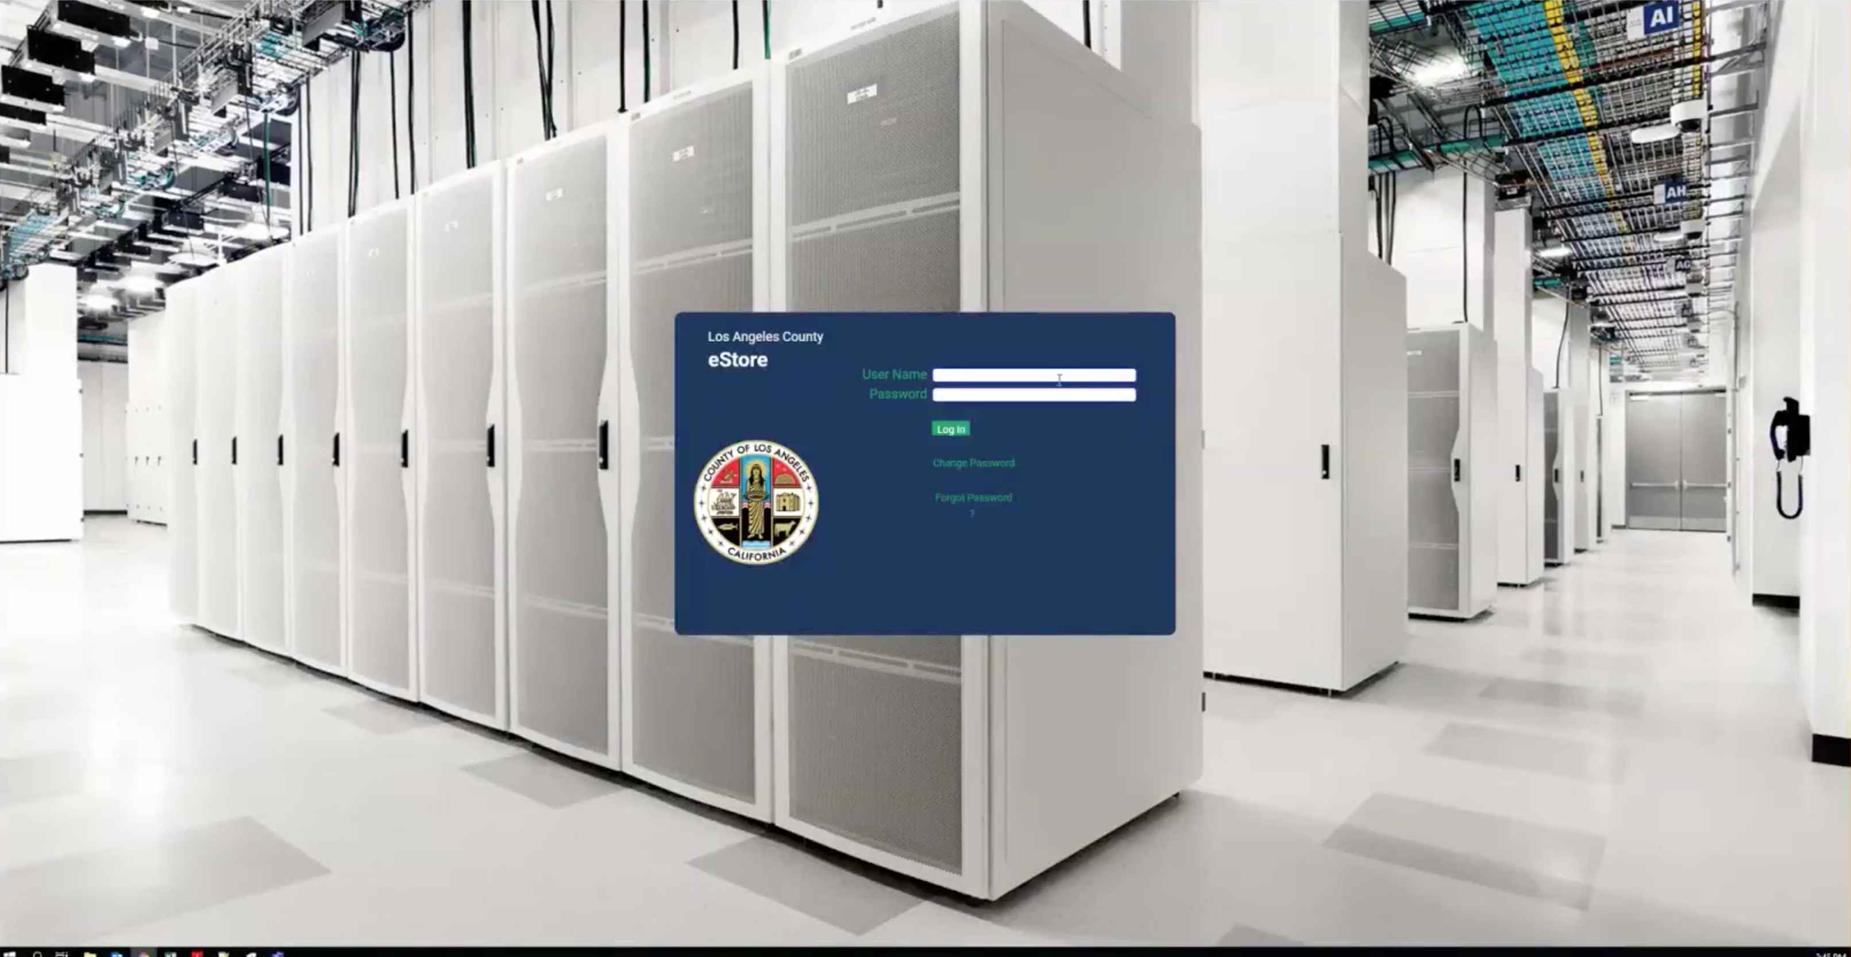

Username/Password

Change password

Forgot password

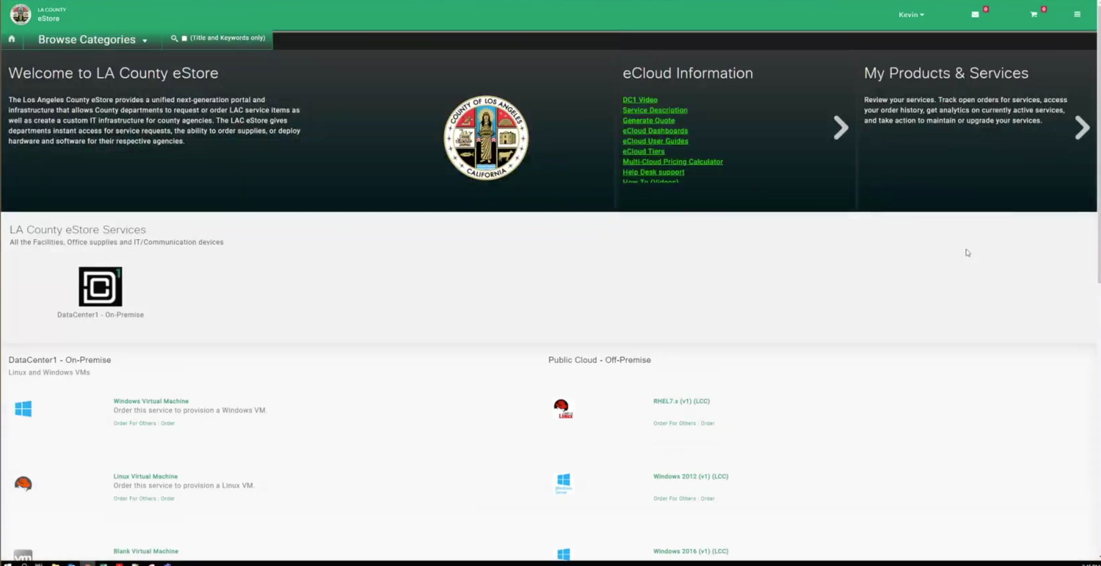

Initial screen

Documentation for users

(on premise support):

Windows VM

Linux VM

Blank VM (probably not used)

Public cloud

RHEL 7.X

Windows 2012

Windows 2016

Chargeback report

ECM

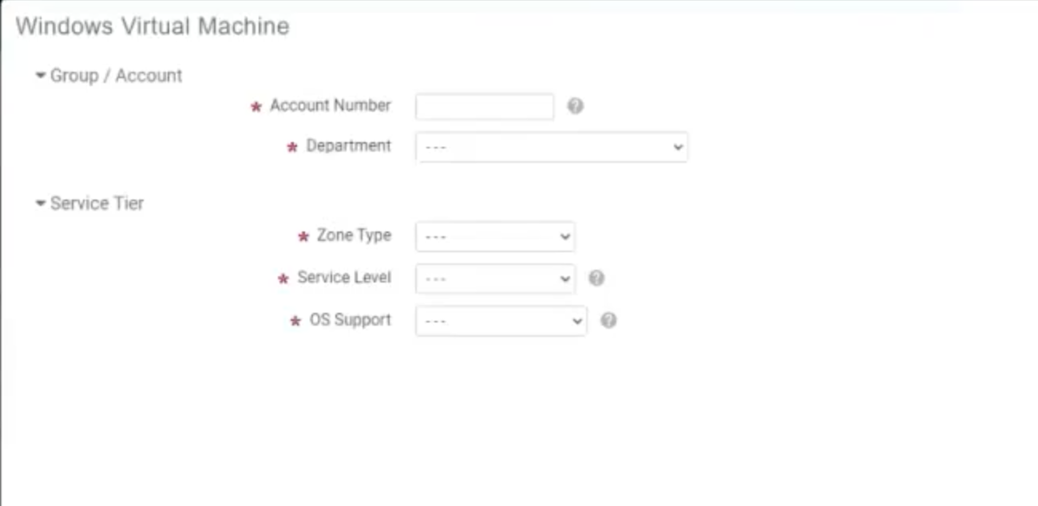

Filled values with dropdown help

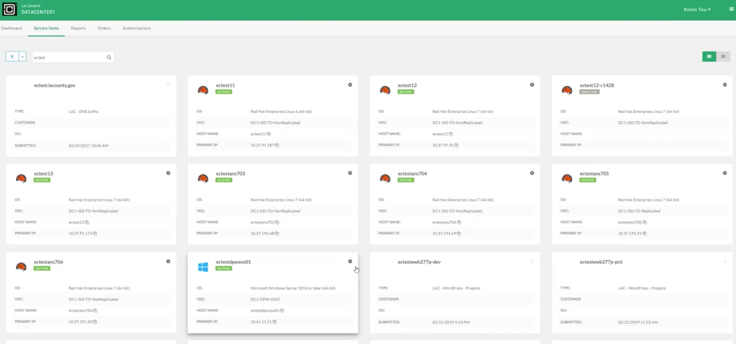

Admins have ability to view all vms

Users can only see their vms

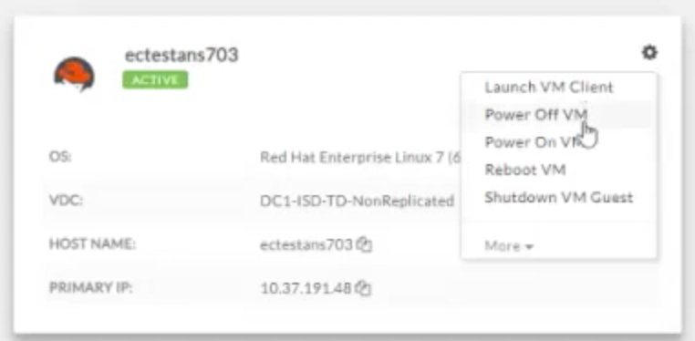

Tasks / Workflows, need ansible for these:

Connect to VM (launch VM client) 🡨- Connect to console

|  |  |
| --- | --- |
| Power off VM | Power on VM |
| Reboot VM | Shutdown VM |
| Clone VM | Create server snapshot |
| Create VM disk | Create VM snapshot |
| Decommission VM | Delete snapshot |
| Delete VM | Delete VM disk |
| Delete VMsnapshot | Delete vNIC |
| Download Snapshot | Enable CPU memory … |
| Extend Snapshot | Install Apps for Windows |
| Install SCOM | Install vScout |
| Modify CPU RAM | Refresh Status |
| Reset VM | Resize VM |
| Revert Snapshot | Revert VM Snapshot |
| Standby VM | Suspend VM |
| Sync VM by VMID | Update Metadata |
| Clone for OCP |  |

Deploying VMS:

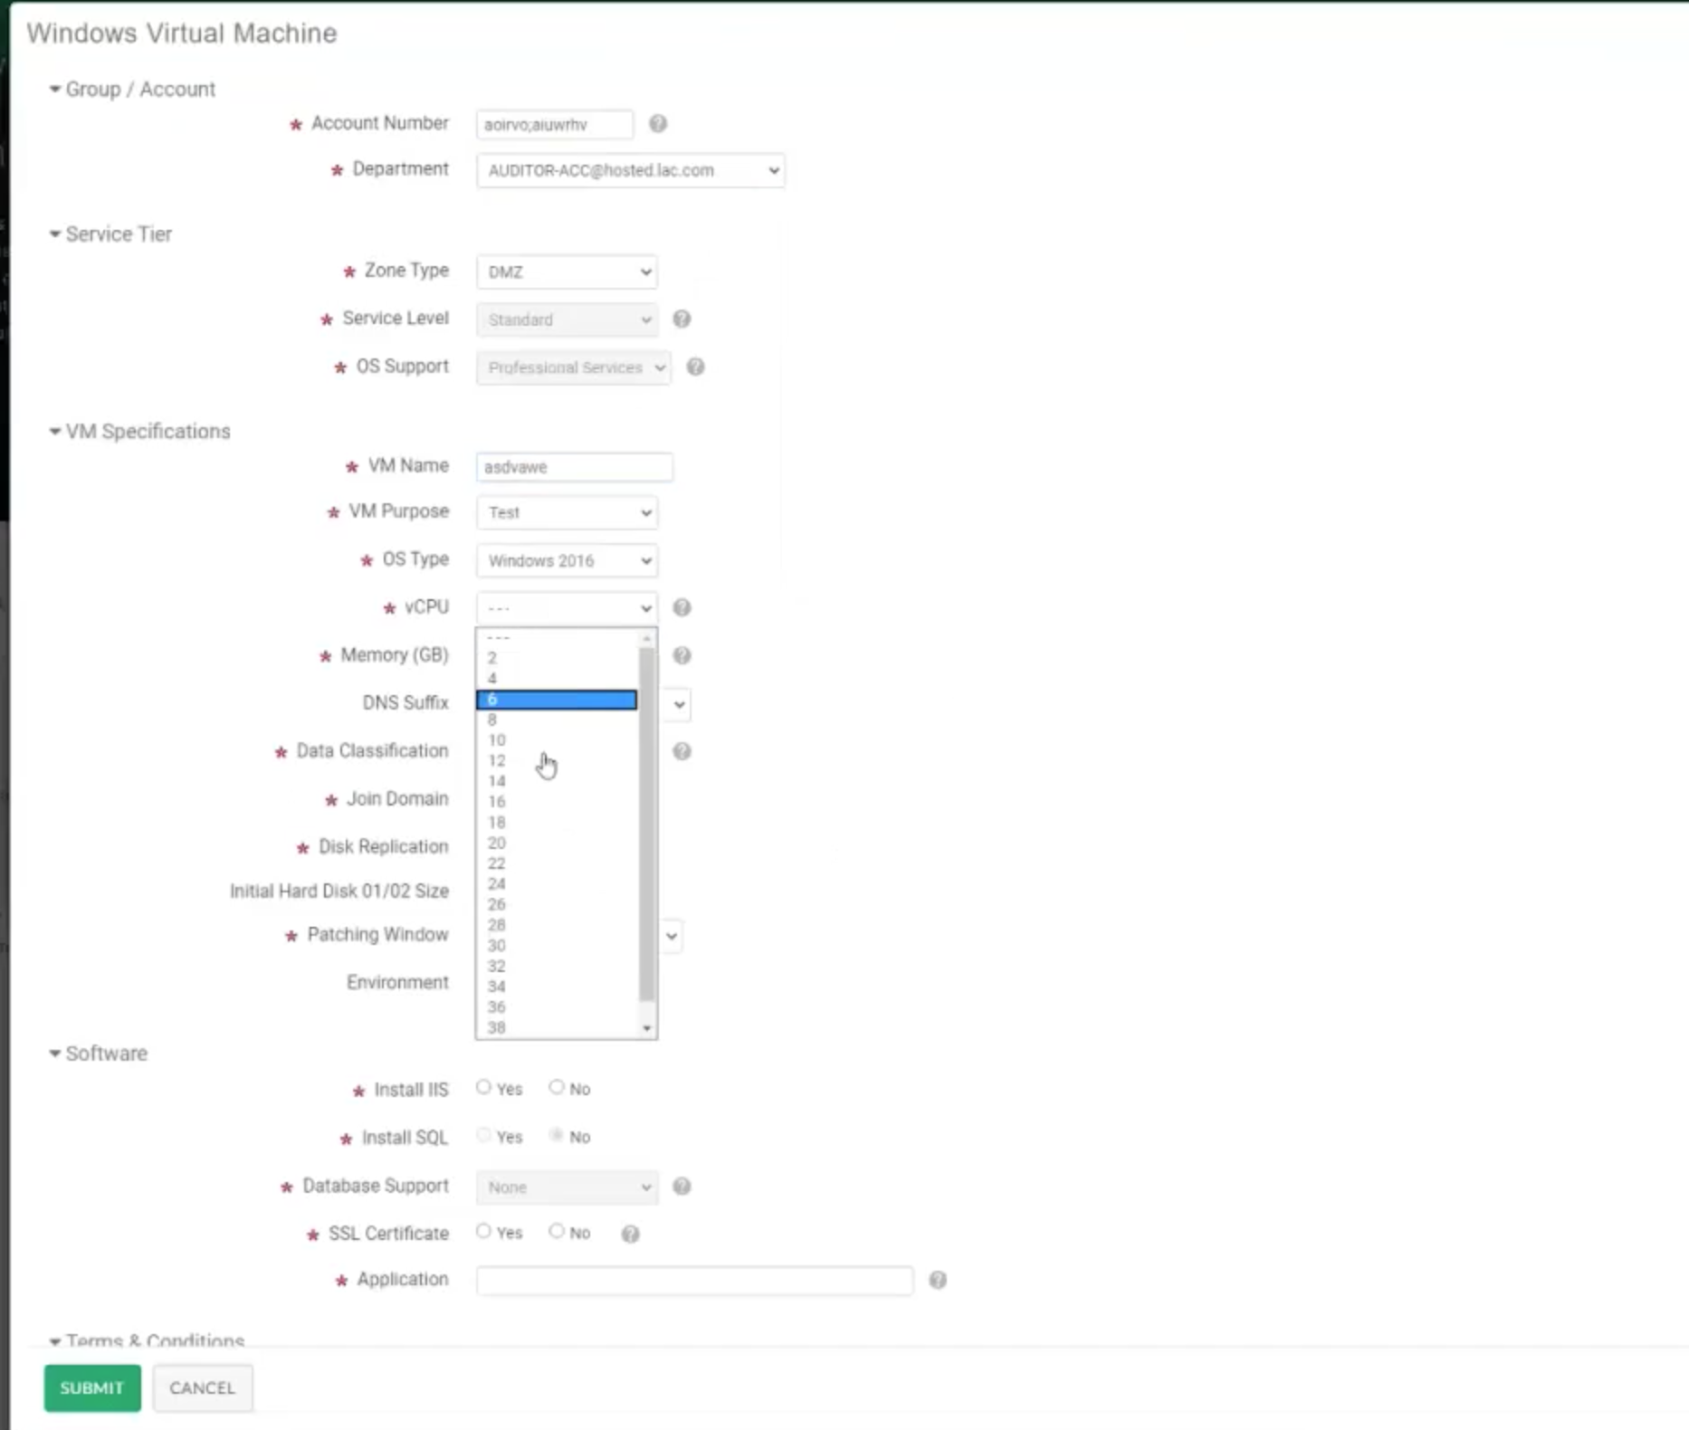

When deploying virtual machines need drop down filled in values which users can choose. Need to determine where these values are gathered.

More:

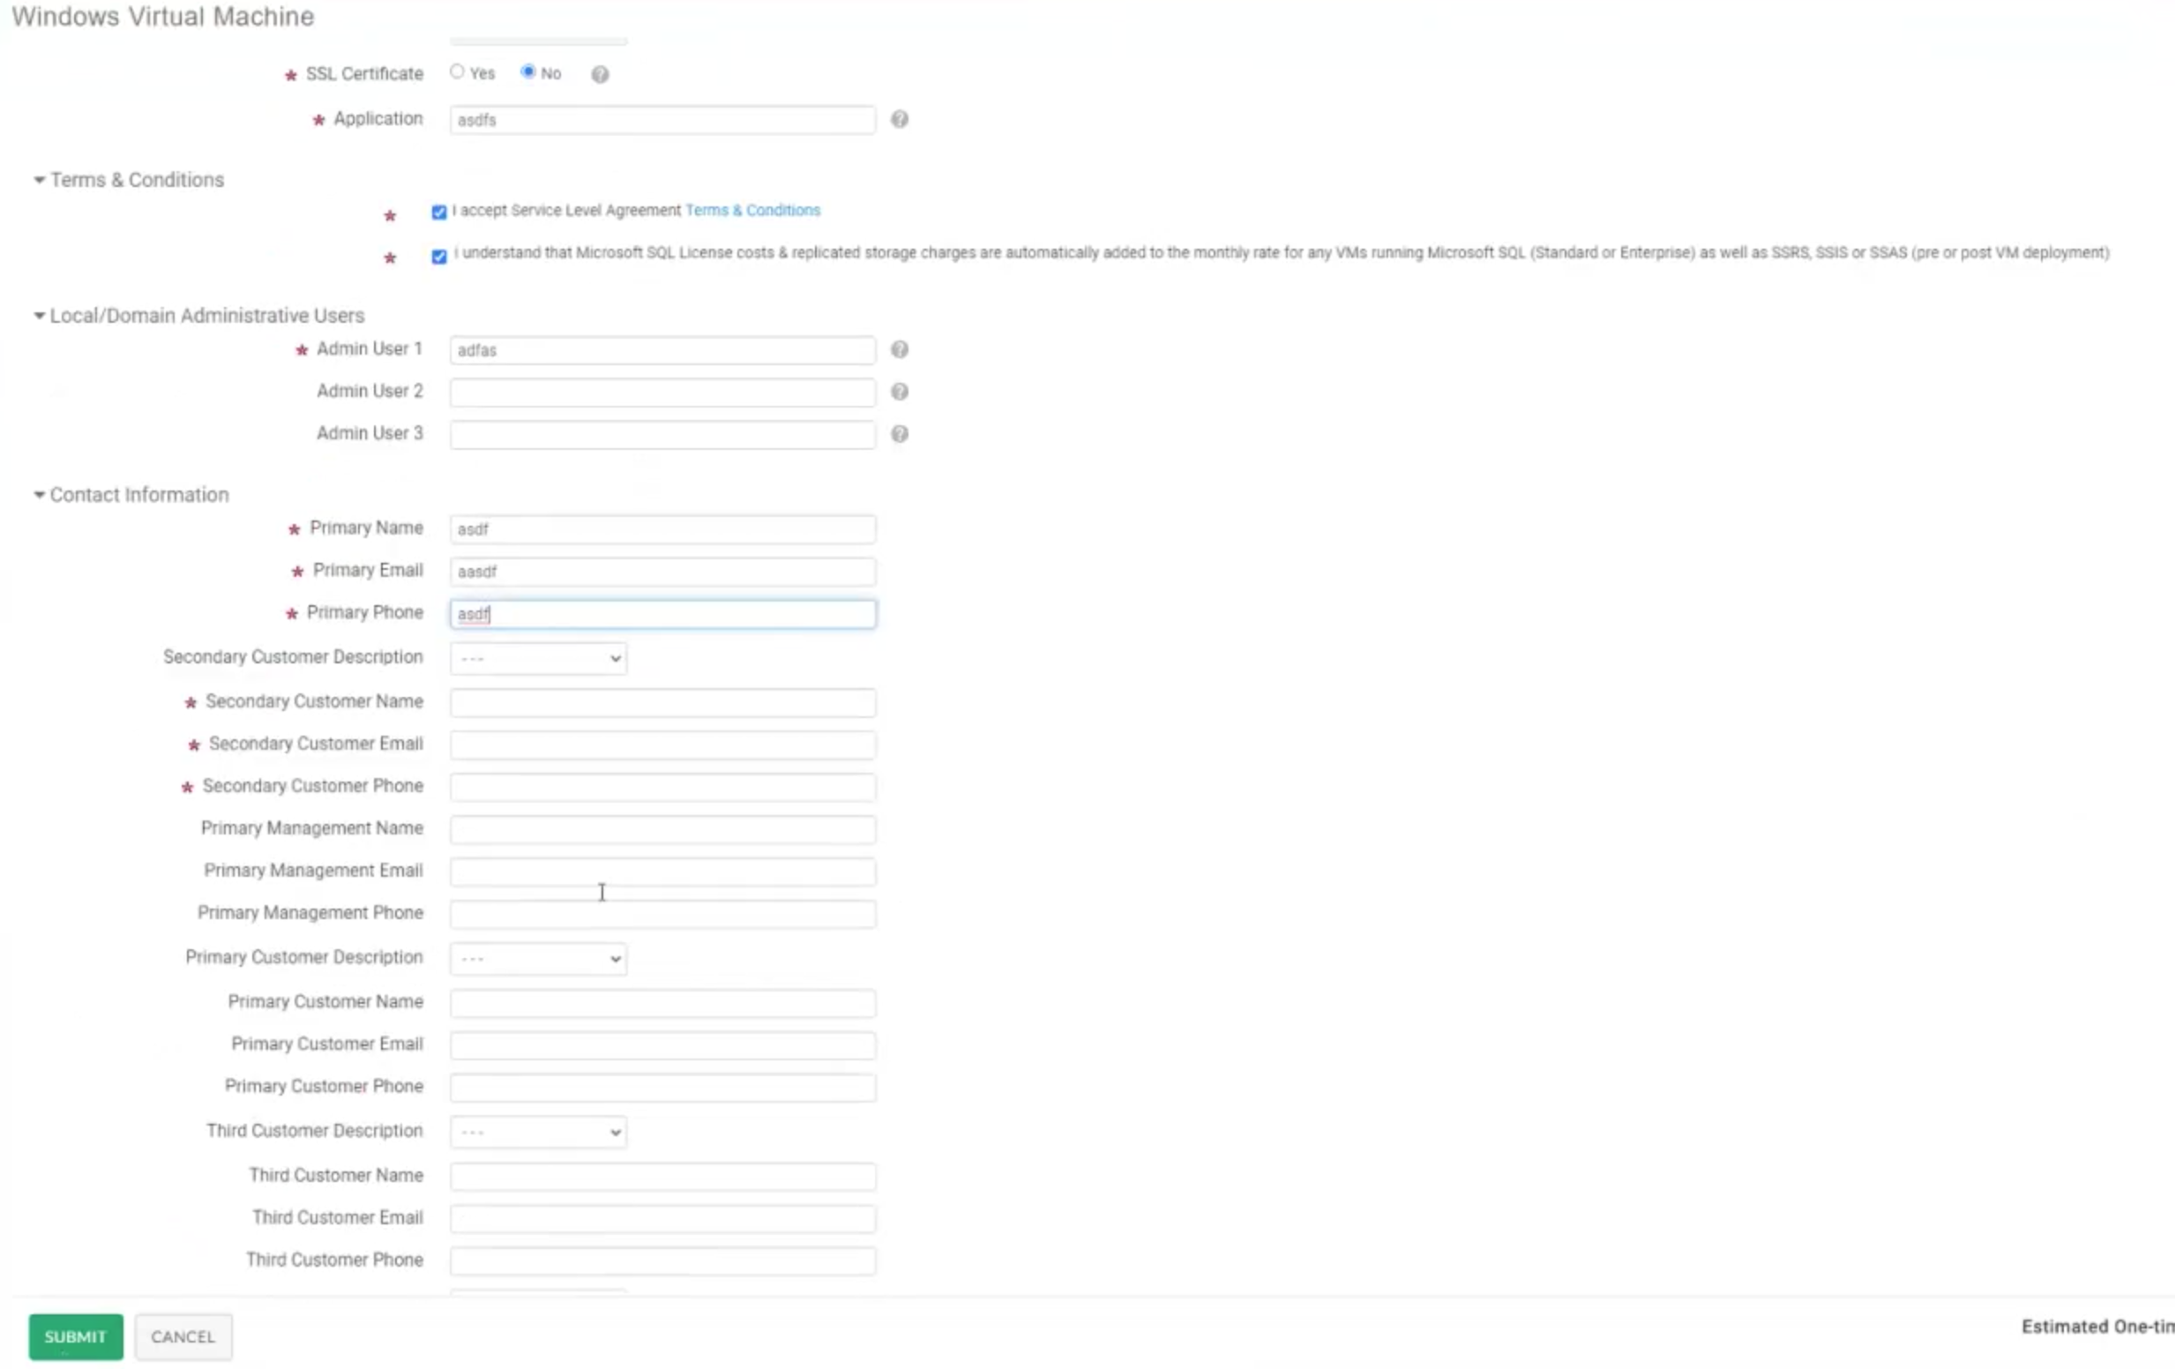

Also bottom has cost estimates:



UCS Director contains all of the workflows:

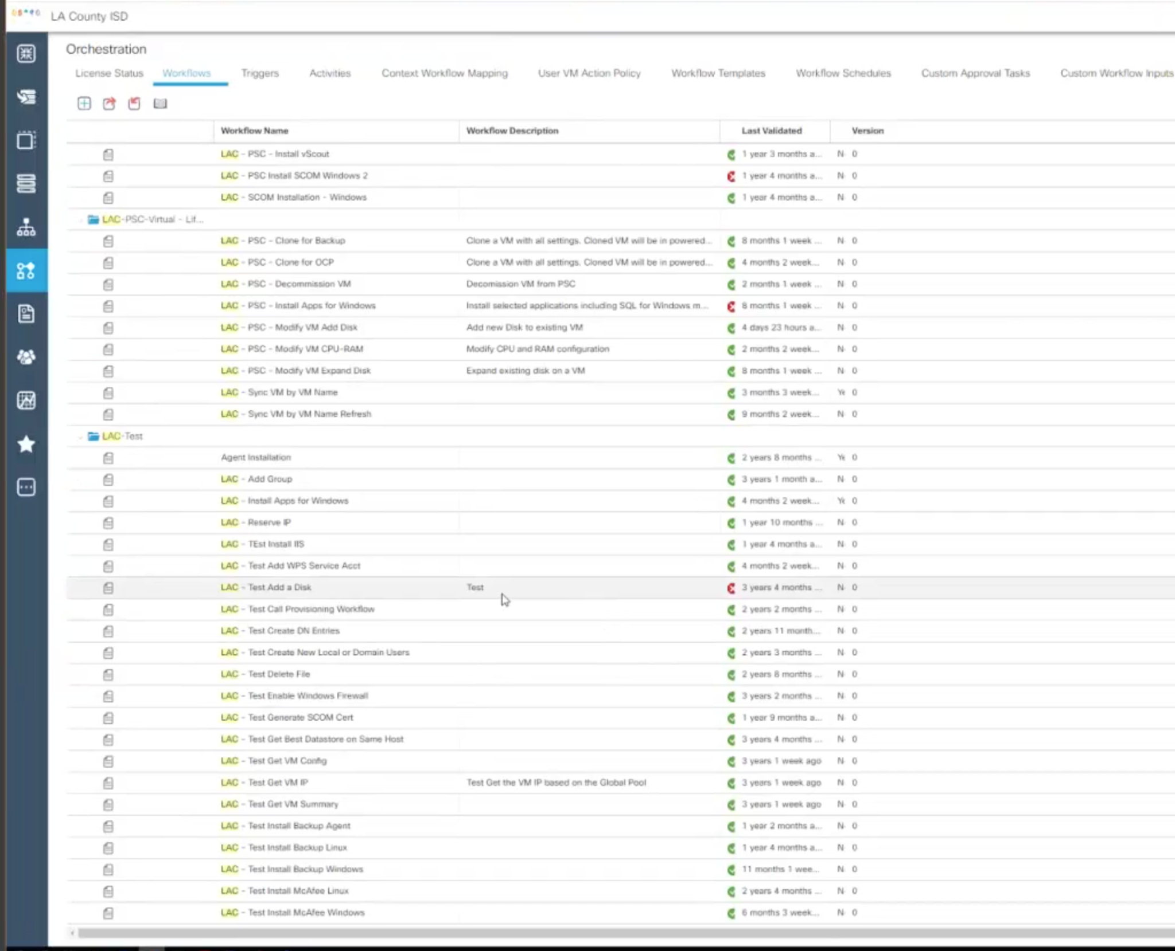

Sample workflow to add a disk:

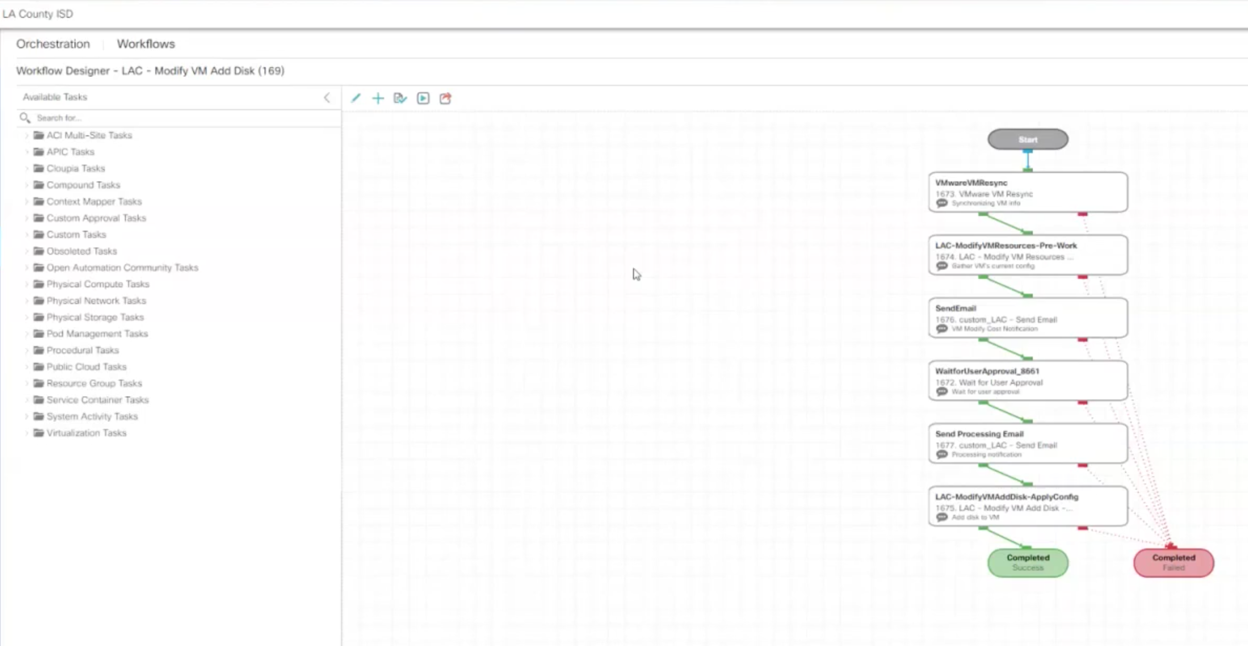

This specific task (Modify VM Add disk):

Does a vmware resync to synchronize VM info

Modifies VM resources

Sends an email to indication cost notification

Waits for user approval

Sends a processing email notification

Performs task to add disk.

This workflow contains an approval workflow, although they did mention they don’t’ do approval worflows.